**Business Aviation in India - An Industry Report by Business Aircraft Operators Association**

1. Growth – type of aircraft and Number of fleet

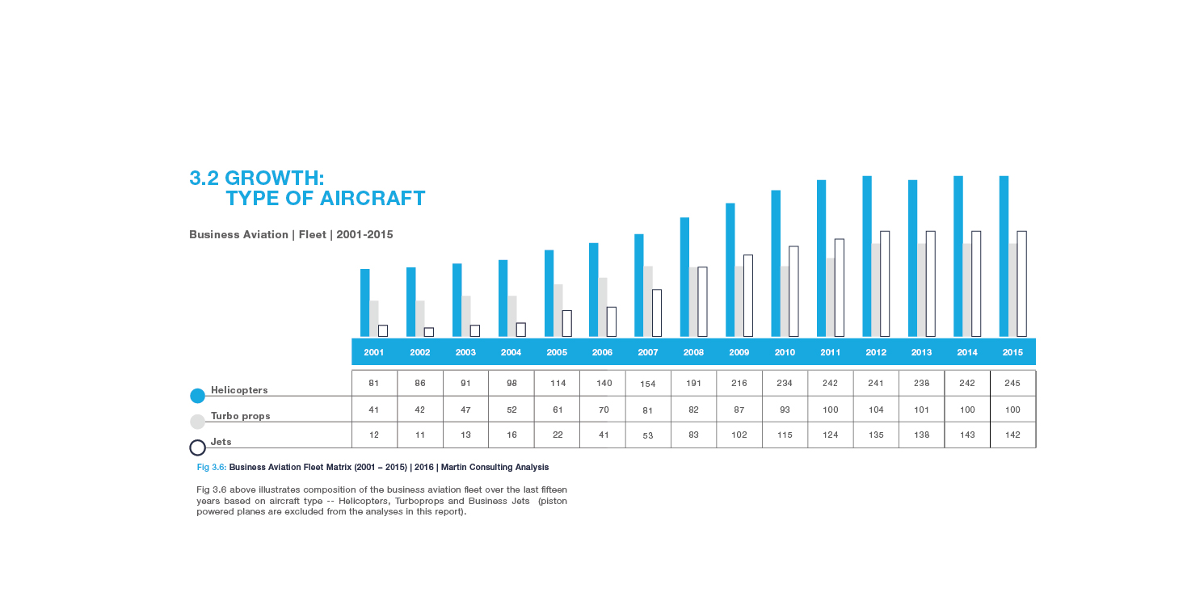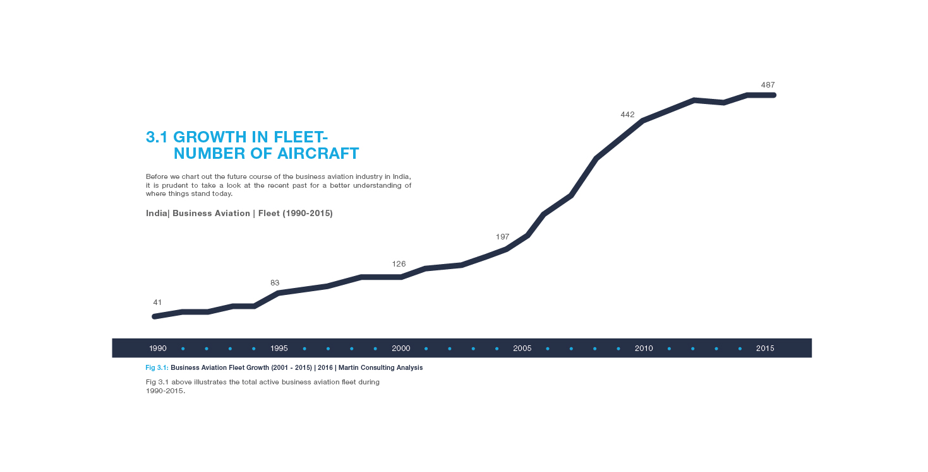

1. Business avaition – contribution to GDP



1. Business Aviation –Growth Forecast



1. The Road Map Ahead – Recommendations

Abolish Import duties

**Recommendation:** The government should rationalize Custom Duty policy on aviation sector, by making the import duty on aircraft to zero percent and thereby entirely remove the anomaly.

This immediate step will help lower costs, kick-start industry growth, bring in much needed operational efficiencies generate employment and provide multiplier economic benefits to India.

**Strengthen the aviation regulator**

**Recommendation:** The government is obligated to support the DGCA through adequate funding and professional manpower to perform its duties effectively. DGCA leadership needs to be people having adequate domain knowledge and experience, with stability of fixed tenures of minimum 3 years to make an impact. Adequate financial independence needs to be granted to hire the right human resource and train them. E-governance is the need of the hour, and this needs to be implemented as soon as possible.

**Fractional Ownership and Aircraft Management**

**Recommendation**: The Government needs to encourage consolidation of NSOP industry through ‘fractional ownership’ and ‘aircraft management’ concepts. The operator, being an aircraft management company, achieves economy of scale by optimally using available resources to manage aircraft belonging to different owners. The Government needs to facilitate these concepts proactively. DGCA, Customs department, DRI should be made aware of these worldwide concepts, needed for lowering the cost of ownership. This will facilitate seamless import of aircraft under separate ownership model. Min. of Finance should be asked to issue clear guidelines for effecting depreciation benefits for different owners.

**Promote business aviation for remote area industrialization**

Recommendation: The Government should recognize the role of business aviation in industrializing remote areas, and support by lowering cost of undertaking business aircraft flights to these areas with incentives as part of new RCS policy: without VGF but lower costs.

**Employ BA aircraft, especially helicopters, during disasters and in the ‘golden hour’ for emergency medevac.**

Recommendation: Until the helicopters of the defence forces arrive, BA resources available close to the disaster site should be utilised. The immediate hiring of BA aircraft at or near the disaster site should be made a national and state policy. Making roof top helipads over all tall buildings in cities across India, should be made a national policy to boost EMS operations and save lives of people The flexibility of helicopters should be freed up to save lives in accidents.

**Airport watch hours**

Recommendation: MoCA, being the nodal body, should facilitate interactions with the MoD and MHA to find a way out and to engage with the respective airport owners, be it AAI, HAL or the military arms, to increase watch hours at important tier-2 and tier-3 city airports. For instance, extension of watch hours at Ozhar, Daman and Surat will help meet up industrial needs and also help partially in decongesting Mumbai airport.

**Exploit technology to transform DGCA regulations and functioning**

Recommendation: The DGCA should move towards digitisation of all records, streamlining and automation of existing processes and procedures. Decentralisation and enabling the regional DGCA offices would also reduce the workload at the DGCA HQ in Delhi. In addition, the regulator needs to align its regulations with world standard practices for which it needs to take outside help.

**Collaborative Rule-making**

Recommendation: The DGCA should form dedicated ‘action committees’ with industry stakeholders to deliberate and discuss all important regulations. Functioning of the proposed Joint Working Group (JWG), with participation of the industry stakeholders, should be most effectively implemented.

**Utilization of Foreign Pilots/Engineers on BA aircraft**

Recommendation: Regulations permitting employment of foreign aircrew/engineers for business aviation aircraft should be made simple and seamless to ensure optimal utilization. Likewise, DGCA should expedite approvals of foreign OEM and MRO applications and make the procedures more user-friendly.

**Flight Duty Time Limitations for Business Aviation**

Recommendation: Different FDTL regulations need to be prepared incorporating specific provisions for landing restrictions, resting time and flight time proportionate to nature of flying undertaken in BA industry.

**Delhi – BA terminal**

Recommendation: The Delhi International Airport Limited (DIAL) should construct a dedicated terminal to house the business and general aviation industry. Until that happens, business aircraft should be given one terminal to operate from and all aircraft should be parked close to each other at nearby bays. All departures, including international departures, need to be conducted from this terminal. Self handling and self maintenance is a right of an operator and thus there should not be any attempt to make operators forcefully outsource it.

**Mumbai – BA aircraft parking and curfew hours**

|  |
| --- |
| Recommendation: Contrary to repeated statements by MIAL, the airport has scope for establishing more parking bays. The isolated 'Lima' bay is unused due to its distance from the airline passenger terminals. This parking bay is located close by to the BA bay / BA terminal and should be offered to BA operators for aircraft parking. A joint committee should be set up for devising procedures and assessing any works (taxi way connection between Lima bay and BA bay) that may be needed. Improved ATM procedures have allowed almost one landing/departure a minute at CSIA. Thus there is need to completely lift curfew timings for BA at Mumbai due to more efficient air traffic management achieved by ATC. Till that happens, limited BA aircraft slots should be given during the curfew periods to cater for emergent needs of BA.  **Future use of general and business aviation** |

Recommendation: General and business aviation constitute a larger fleet than scheduled airlines. They also make a significant contribution towards the Indian economy. The fast growing Indian economy will soon need more and more of BA activities to propel India into the league of developed nations. The road, rail and power projects, in remote and inaccessible areas of the nation, would essentially require optimal use of BA aircraft for efficiency and speed of executing such projects. A separate well defined five-year plan for BA should be prepared by government to achieve higher growth rate for Indian economy.

**Creation of Strategic Governing Board**

Recommendation: MoCA should take the lead by forming a joint coordination strategic committee with representatives from Defence, Home and other relevant ministries to address this legitimate concern of the industry. Industry professionals visiting India for the purpose of operations/engineering related work in civil aviation need to be expeditiously facilitated at airports and other Government offices. All Government offices should be sensitised by MoCA through the PMO office, on the importance of expeditious decision making in aviation matters.

**Business aviation airports to boost ‘Make in India’ campaign**

Recommendation: The government needs to provide an environment for dedicated BA airports on the outskirts of Delhi/Mumbai for facilitating growth in business aviation. This will ultimately give a boost to the ‘Make in India’ initiative, provide ease of doing business with much needed speed and flexibility, also benefiting slow moving remote regional aviation aircraft**.**

**Manufacturing aircraft components in India as part of ‘Make in India’ initiative**

Recommendation: With the aim to gradually make India an aircraft manufacturing hub, a beginning has to be made by actively encouraging businesses to manufacture certified aircraft parts, components, and assemblies to save foreign exchange. Joint ventures with reputed OEMs will help gain vital expertise, all the while moving towards setting up aircraft assembly lines for small BA aircraft. To support this initiative, industrial and investment policies will need to be realigned to encourage the OEMs to form joint ventures with Indian companies.

**Skill development as part of ‘Make in India’ initiative**

Recommendation: MoCA has already drawn up plans to set up a National Aviation University (NAU) to develop the necessary skills. BAOA too will soon embark upon its ambitious plan to start its own training academy to meet the long felt requirements of the BA industry. There is a need to synergize its efforts with the government’s plans on the NAU.

**Separate regulations – Fixed/rotary wing, BA sub-sectors**

Recommendation: It is high time the DGCA comes out with specific and proportionate regulations governing BA operations and develop standard operating procedures (SOPs) for helicopter operations covering all roles that these helicopters are capable to perform

A dedicated BA cum rotary wing division must be set up and cover all departments of DGCA, directly under a JDG level officer.

Separate regulations for BA including helicopter operations is the need of the hour as this will greatly improve the operating environment for all sectors.

**Separate routes/air corridors for helicopters**

Recommendation: DGCA should permit the use of Performance Based Navigation (PBN) for helicopter operations. PBN helps aircraft fly closer together with the aid of creative 3D takeoff and landing approaches. This will greatly help in decongesting our clogged airspace by supporting smaller separation intervals between aircraft.

In collaboration with the AAI, the DGCA should establish separate routes and air corridors for helicopters at all major airports.

**Rationalisation of airport charges**

Recommendation: AERA must clearly demarcate between aeronautical/non-aeronautical services at an airport and ensure that the user charges being levied by our airports for providing services to BA are appropriate, fair and consistent with the quality of services rendered.

**Exploit BA aircraft, especially helicopters for nation building**

Recommendation: BA aircraft, especially helicopters, must be exploited to boost sub-sectors, such as medevac & disaster relief (covered in 7.1.3.1), tourism, pilgrimage, surveys, oil exploration, power line transmission, agriculture, internal security, policing, helicranes and heli-sports. The government needs to build infrastructure and implement polices to support such operations.

**Permanent helipads in all districts** to support Disaster Relief and Regional Air Connectivity.

Recommendation: All state governments should be encouraged and mandated to construct permanent helipads in each district with the necessary support infrastructure.